Computer Shop System

Use-Case Specification: Edit staff profile

Version 1.0

Revision History

|  |  |  |  |
| --- | --- | --- | --- |
| **Date** | **Version** | **Description** | **Author** |
| 15/12/2019 | 1.0 | details | Hoang Trung Hieu |
|  |  |  |  |
|  |  |  |  |
|  |  |  |  |

Table of Contents

1. Use-Case Name 3

1.1 Brief Description 3

2. Flow of Events 3

2.1 Basic Flow 3

2.2 Alternative Flows 3

2.2.1 < First Alternative Flow > 3

2.2.2 < Second Alternative Flow > 3

3. Special Requirements 3

3.1 < First Special Requirement > 3

4. Preconditions 3

4.1 < Precondition One > 3

5. Postconditions 3

5.1 < Postcondition One > 3

6. Extension Points 3

6.1 <Name of Extension Point> 3

Use-Case Specification: Edit staff profile

# Use-Case Name

## Brief Description

This use case helps computer store manager to be easier to update or edit some personal information that employee can change over time such as address, phone number, position and etc.

# Flow of Events

## Basic Flow

The first step is that manager selects updating profile function in the system. Next, he/she searches following by name the profile wanting to change or edit. System will validate the name that manager entered before. If this name is existed, system will return a list of profiles which appear this name. Manager’s aim is choosing one profile that he/she wants to edit or update. Then, system displays this selected employee’s profile in details. Some information in this profile is edited by manager. After that, manager submits updated form, system saves all of changes in database and displays a sucessful message. This process ends.

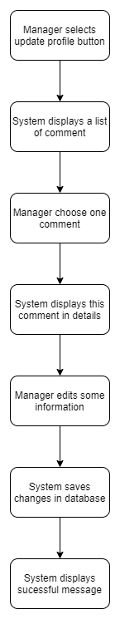

**2.2**. **Alternative Flows**

**2.2.1.** **Valid name**

If in step 3: validate name of this use case: Validate name is not successful, that means name is not found, then process ends.

# Special Requirements

- No empty required fields such as name, phone number, email, date of brith, position.

- Have correct form of some fields:

+Email need ‘@’

+Phone number is integer

+Password and repeat password is the same

# Preconditions

Manager need to log in system and select profile management function.

# Postconditions

No postconditions.

# Extension Points

None.